**Getting Started**

**How to use SensiBLE 1.0 with ARDUINO IDE (Win10)**

1. Download and install the latest [**Arduino IDE**](https://www.arduino.cc/en/Main/Software).

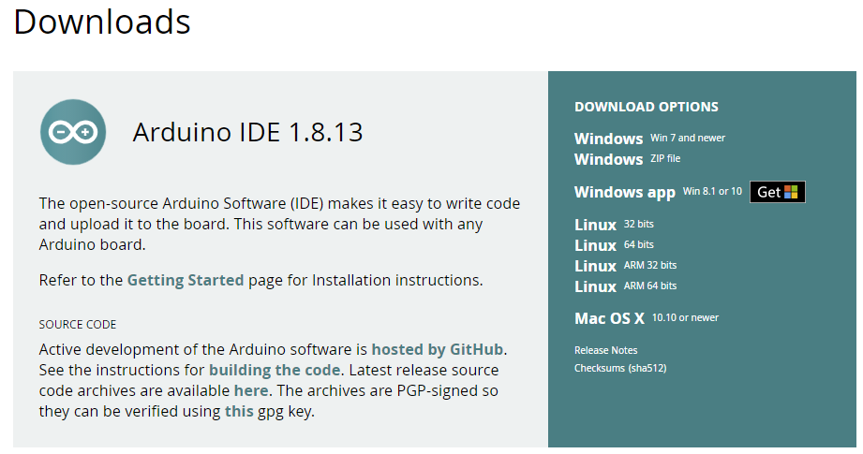

1. Launch Arduino IDE.  
   Click on **File** menu and then **Preferences**  
   The Preferences dialog will open, then add the following link to the **Additional Boards Managers URLs** field:

***https://github.com/stm32duino/BoardManagerFiles/raw/master/STM32/package\_stm\_index.json***

1. Click **Ok**    
   See below.

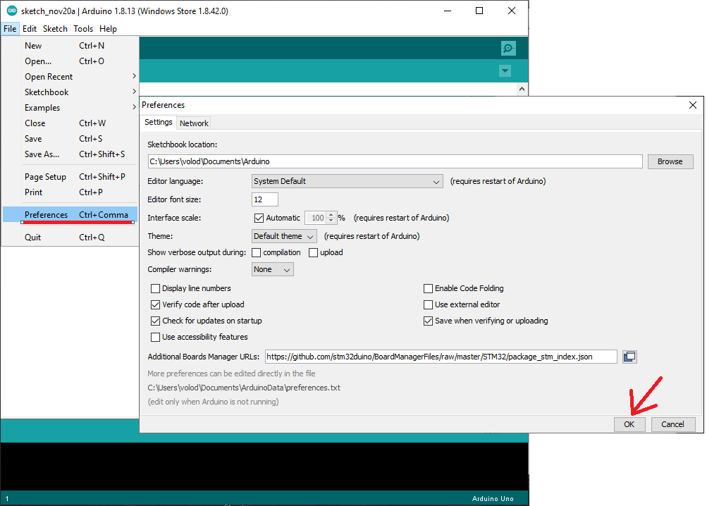

1. Click on **Tools** menu and then “**Boards** > **Boards Manager**”  
   Next in the box type: **stm32**  
   and install all the boards that appears.  
   See below.

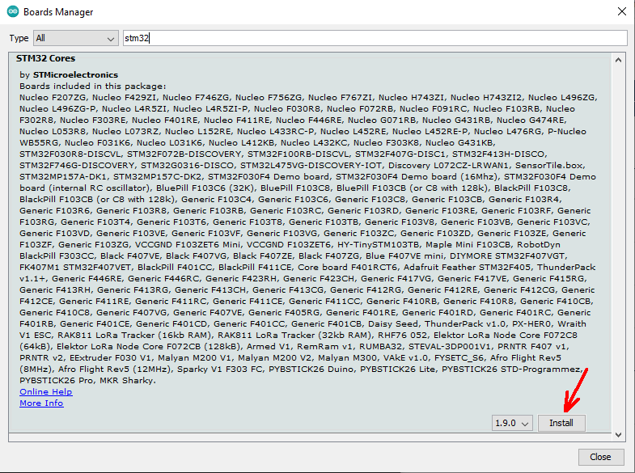

1. Now select again: **Tools** > **Boards**  
   and choose the **NUCLEO-64** board.

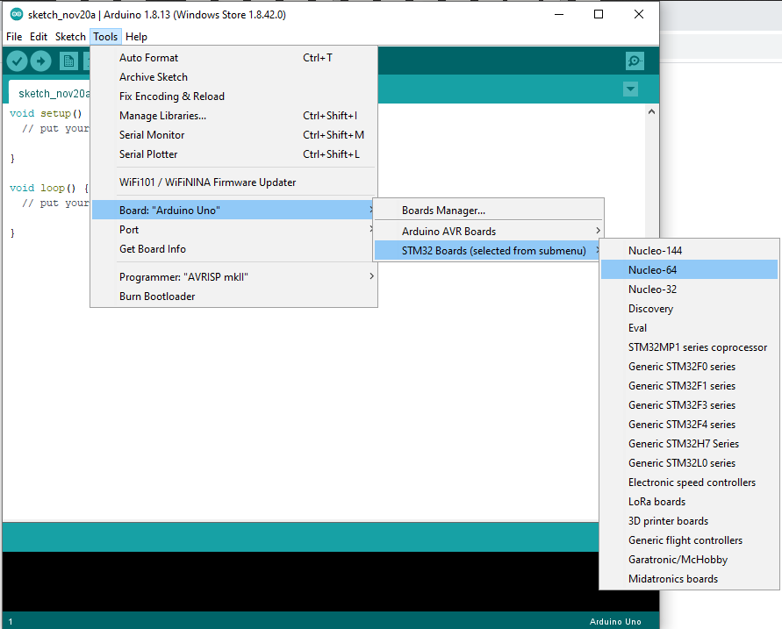

1. Now select again: **Tools** > **Board part number**  
   and choose the **NUCLEO L476RG**

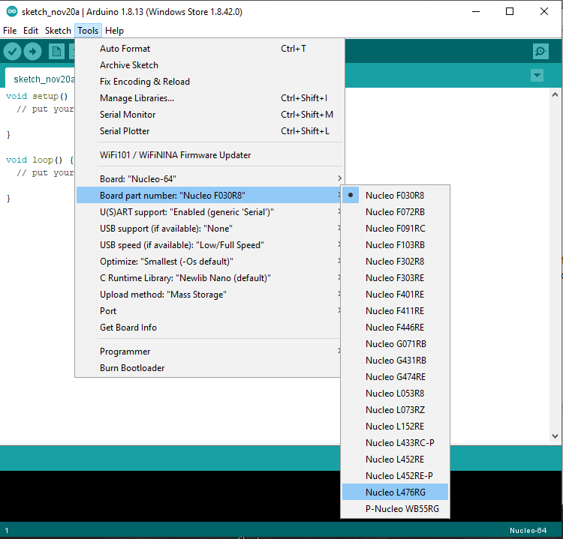

1. Now select again: **Tools**   
   and choose the next:

* U(S)ART support: “Enable (generic ‘Serial’)”
* USB support (if available): “None”
* USB speed (if available): “Low/Full Speed”
* Optimize: “Smallest (-Os default)”
* C Runtime Library: “Newlib Nano (default)”
* Upload method: “STMCubeProgrammer (SWD)”

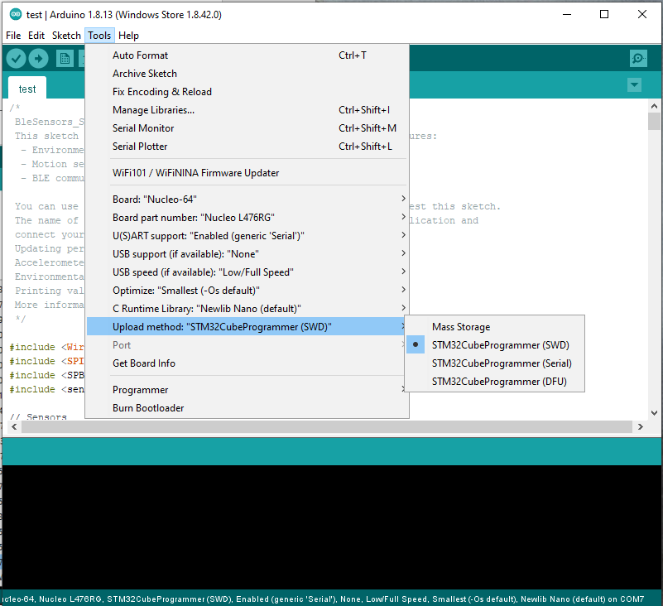

1. Now connect **SED-PRO** with **SensiBLE** to computer via USB,

select **Tools** > **Board part number**

and choose the available port:

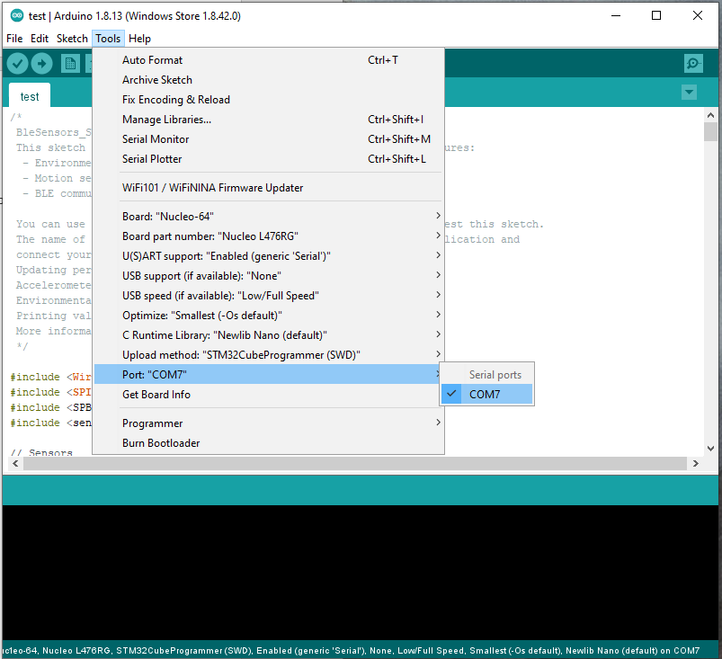

1. Download and install the [STMCubeProgrammer](https://my.st.com/content/my_st_com/en/products/development-tools/software-development-tools/stm32-software-development-tools/stm32-programmers/stm32cubeprog.html" \t "_blank)

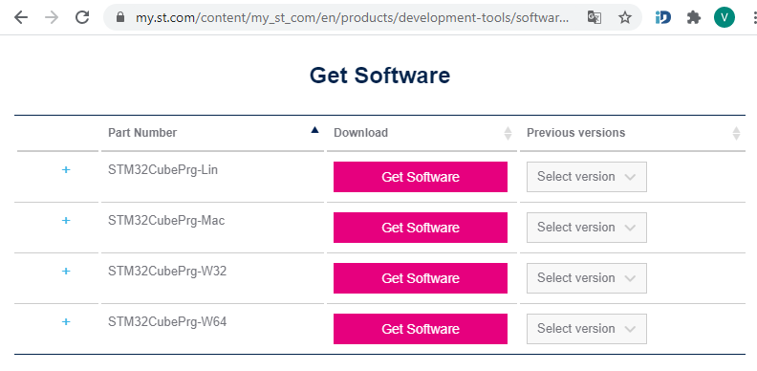

1. Run the [STMCubeProgrammer](https://my.st.com/content/my_st_com/en/products/development-tools/software-development-tools/stm32-software-development-tools/stm32-programmers/stm32cubeprog.html" \t "_blank) and select “Firmware upgrade” if available Serial number: “Old ST-LINK…”

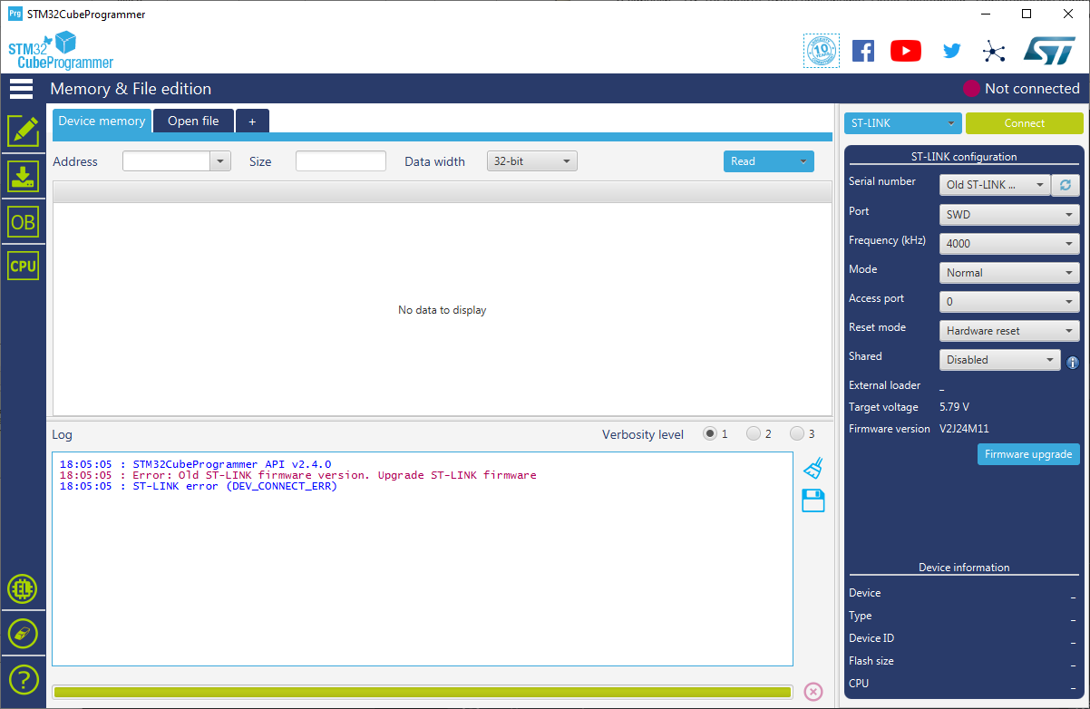

1. Press **Open in update mode**. If need, press twice.

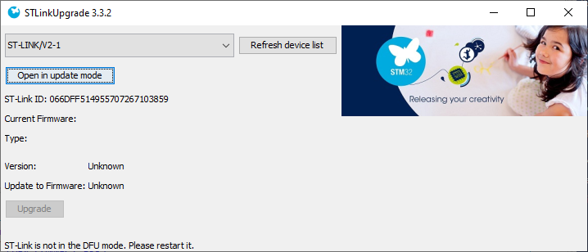

1. Press **Upgrade** and close all STMCubeProgrammer windows after correct upgrade.

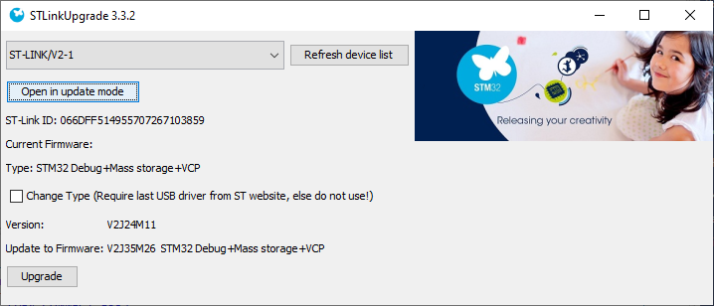

1. Now select again: **Sketch** > **Include Library** and choose the **Manage Libraries…**

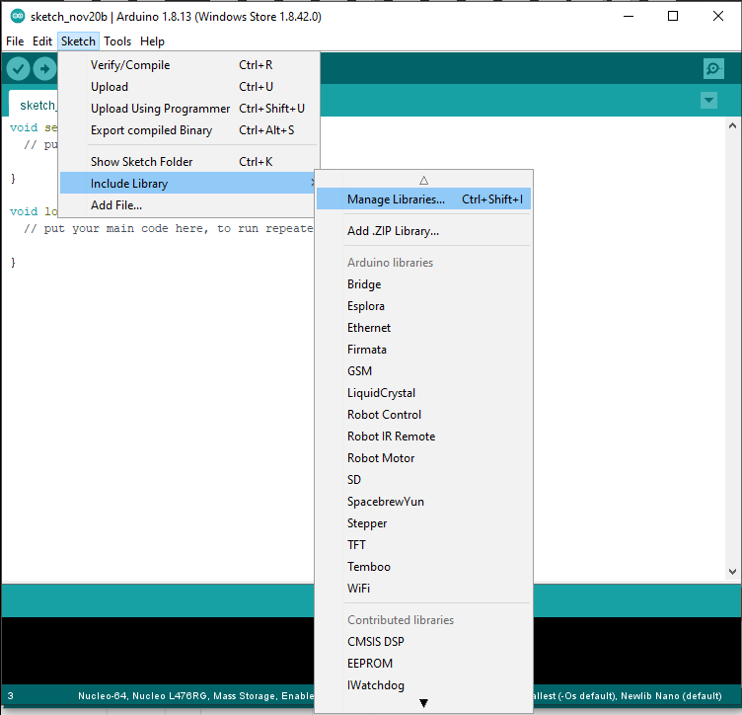

1. Next in the box type: **SPBTLE\_RF**  
   and install next library.  
   See below

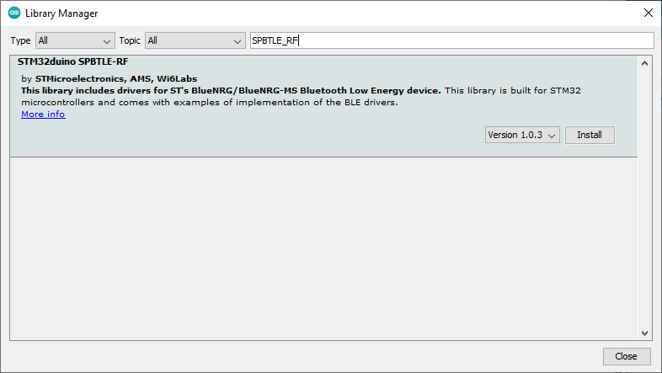

1. Repeat #13 and next in the box type: **HTS221**  
   and install next library **STM32duino HTS221**.  
   See below

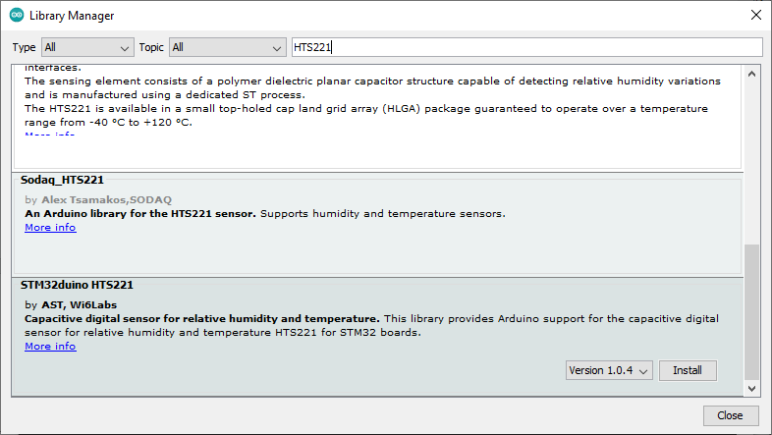

1. Repeat #13 and next in the box type: **LIS3MDL**  
   and install next library **STM32duino LIS3MDL**.  
   See below

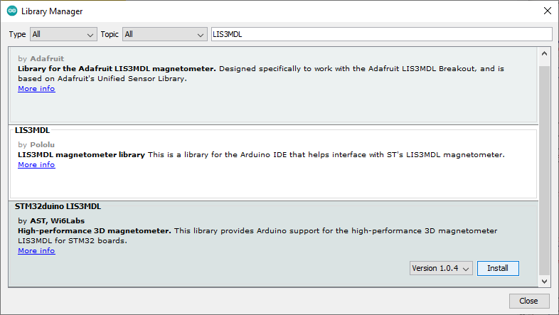

1. Repeat #13 and next in the box type: **LSM6DS3**  
   and install next library **STM32duino LSM6DS3**.  
   See below

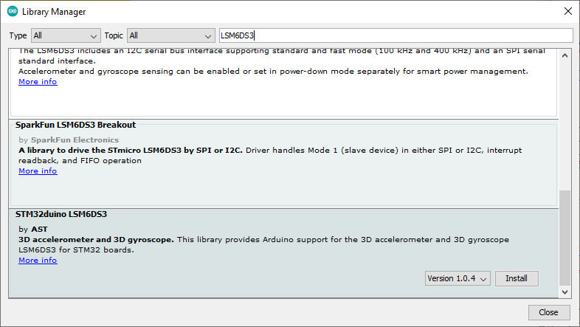

1. Repeat #13 and next in the box type: **LPS25HB**  
   and install next library **STM32duino LPS25HB**.  
   See below

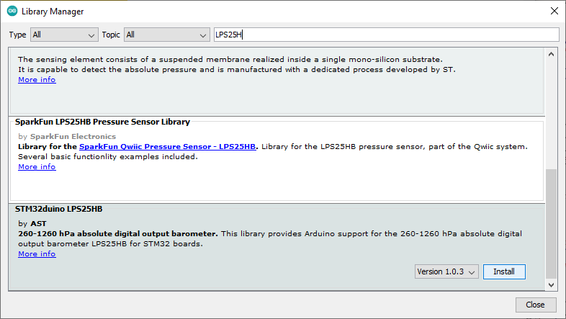

1. Repeat #13 and next in the box type: **VL53L0X**  
   and install next library **STM32duino VL53L0X**.  
   See below

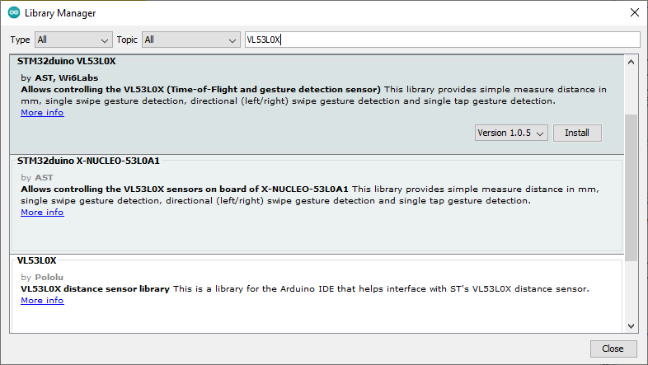

1. Repeat #13 and next in the box type: **VEML6075**  
   and install next library **SparkFun VEML6075 Arduino Library**.  
   See below

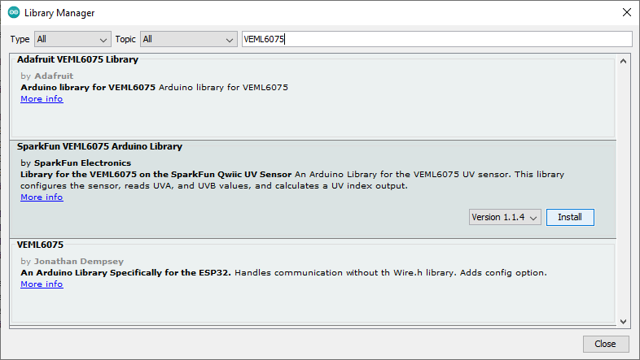

1. Download from ***https://github.com/SensiEDGE/SensiBLEDuino/blob/main/APDS9250.zip*** library for APDS9250.

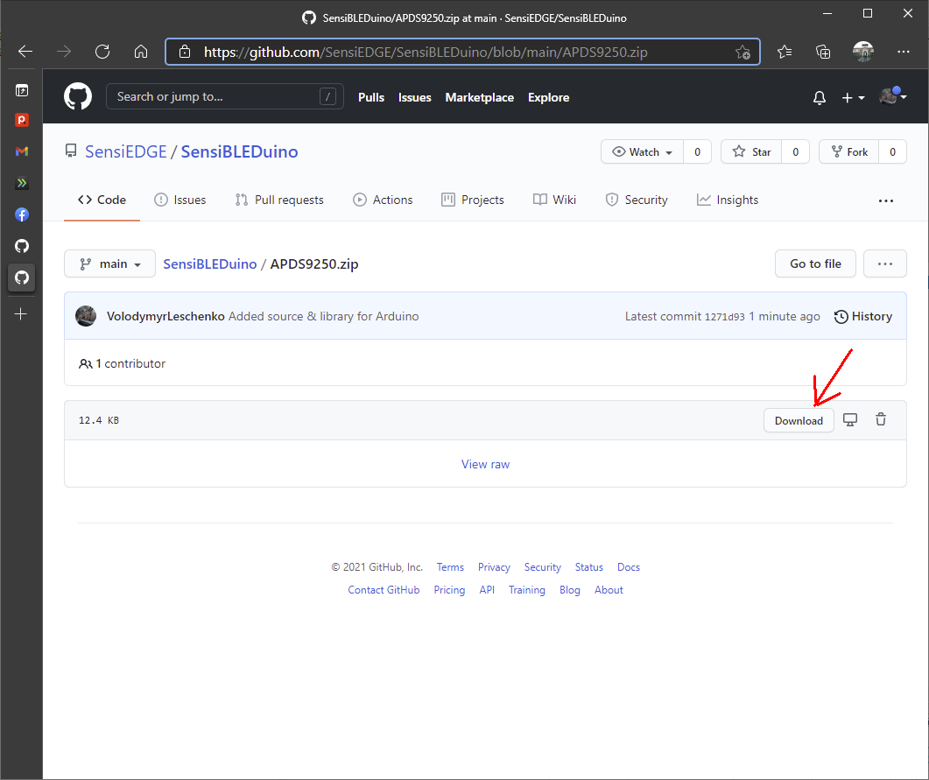

1. Install APDS9250 Library into Arduino IDE. Select again: **Sketch** > **Include Library** and choose the **Add .ZIP Library…**

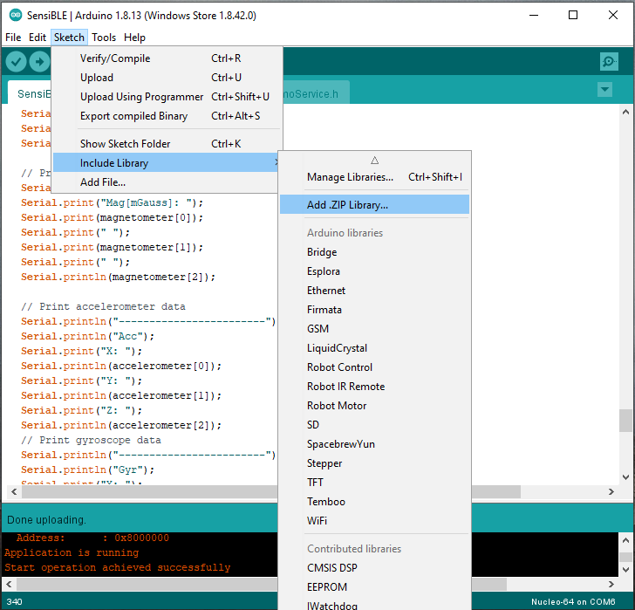

1. Select file **APDS9250.zip** and choose the **Open**

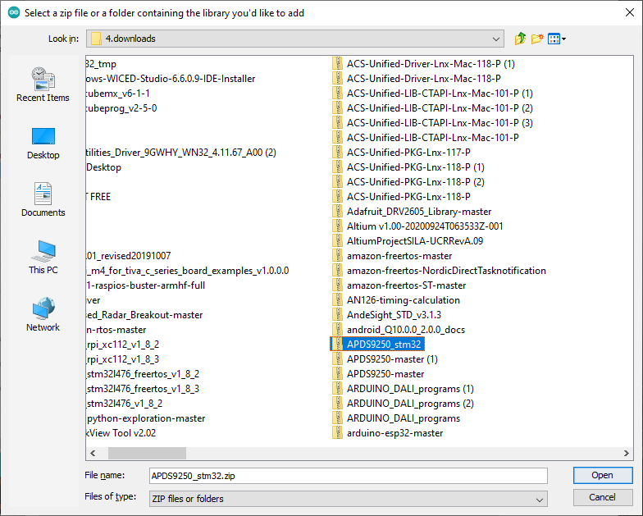

1. Download from ***https://github.com/arduino-libraries/MadgwickAHRS*** library for MadgwickAHRS algorithm.

Select ***Code*** and ***Download ZIP***

See below

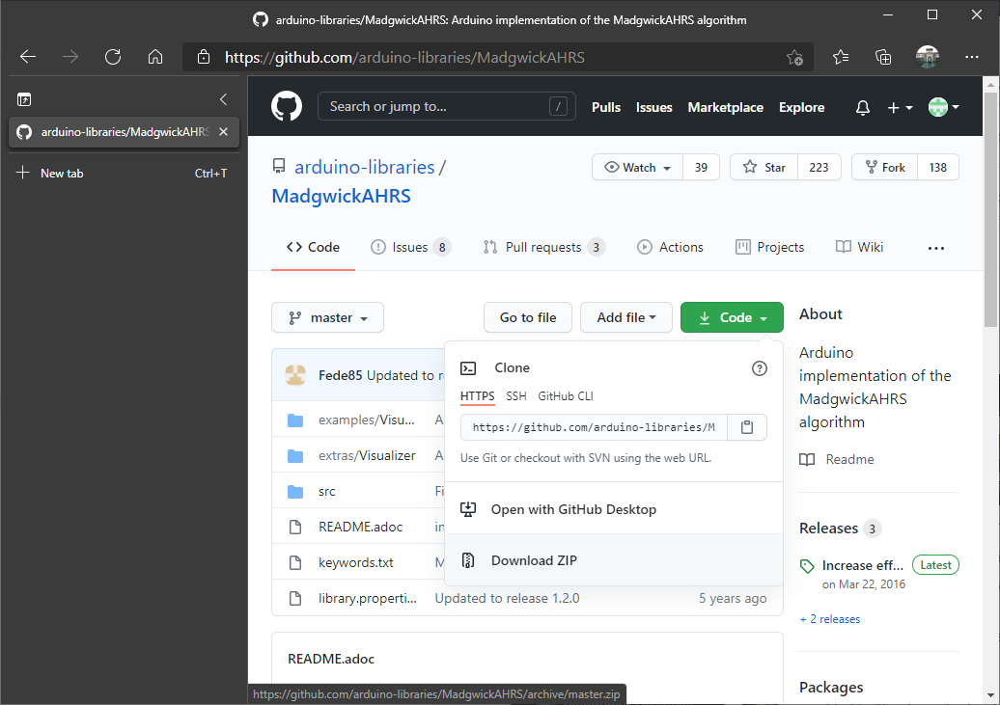

1. Install Madgwick Library into Arduino IDE. Select again: **Sketch** > **Include Library** and choose the **Add .ZIP Library…**



1. Select file **MadgwickAHRS-maste.zip** and choose the **Open**

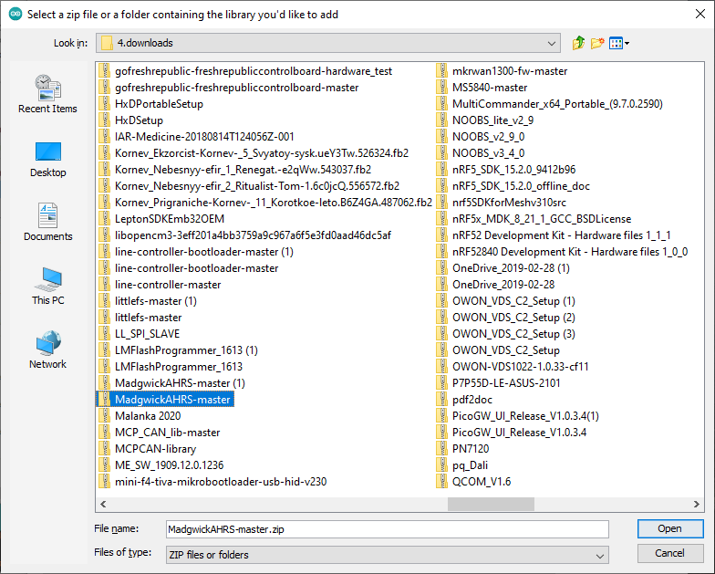

1. Download SensiBLE.zip from ***https://github.com/SensiEDGE/SensiBLEDuino/blob/main/SensiBLE.zip***, unpack to your work directory and to open SensiBLE.ino.

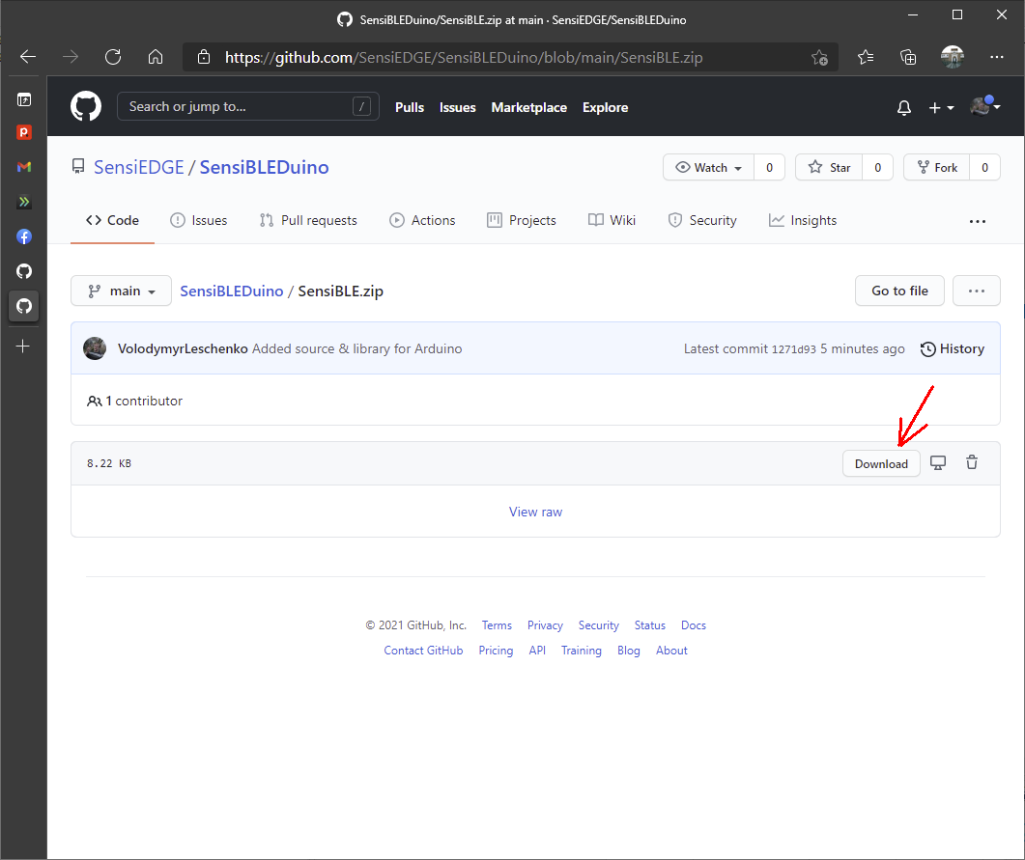

Press Upload button and open into your smartphone application “ST BLE Sensor”. Enjoy!  
